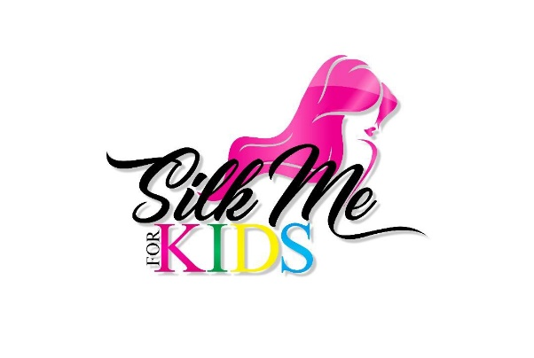

June 2020
To Our Future Sponsors

On behalf of Silk Me Kids and the Hair Glam Squad Pop-up Experience, we, Kerry Holdings Inc Management Team, are thrilled to officially have Megan “Meme” Kelly as a Business and Client on our roster. To be included in such a remarkable journey of Silk Me Kids and the Hair Glam Squad Pop-up Experience is truly humbling, inspirational, and an adventure we would like you to join. The Hair Glam Squad Pop-up provides the ultimate Salon Experience.
From having a major sponsorship with CANTU Beauty Products, interviewed and media coverage by TALK THAT NOLA TV, and being the coordinator for the biggest Essence Pop-up Shop for small businesses for the past seven years, Meme and the Hair Glam Squad Pop-up Experience is one of the most talked about and notable experience that people look forward to every year.
We, Kerry Holdings Inc, are officially inviting you to be one of the Official 2021 Sponsors for the Essence 2021 Hair Glam Squad Pop-up Experience taking place July 2nd, 2021 - July 4th, 2021. Your support would truly be beneficial and never forgotten. Can we count on your support to be a part of the Essence Glam success?
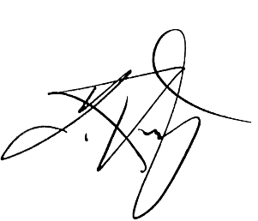
In advance, we THANK YOU for supporting the Hair Glam Squad Pop-up Experience as a 2021 Sponsor! www.HairGlamSquad.com

John R Kerry
Managing Partner/President
Kerry Holdings Inc

(985) 804-7340
www.KerryHQ.com
staff@KerryHQ.com

Included in this package are as follows:
Sponsorship Letter | Meme’s Bio | Sponsorship Form
Introducing the Megan “MeMe” Kelly

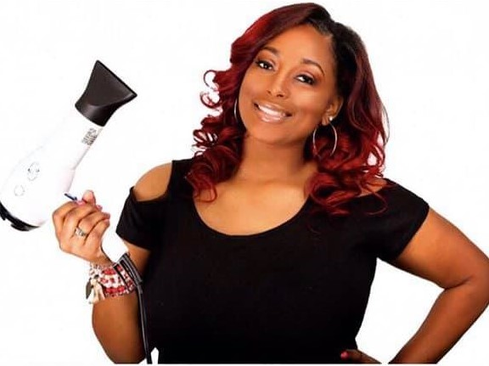
Megan “Meme” Kelly is a licensed cosmetologist and founder of Silk Me Kids in New Orleans, Louisiana a premiere beauty experience for youth. Meme received her cosmetology education & training from John Jay Beauty College in 2013. She always knew her passion was to help women in a way that not only revitalized their look, but also made a positive impact on their feelings of self-worth and esteem.
Over the years, Meme began to see the need for hair care for kids. Observations and countless conversations with parents occurred regarding hair care manageability such as moisture, hair repair, detangling, growth, softness, and other various hair needs. Silk Me Kids hair care products was developed and launched Fall 2017.
In conjunction with her business and being an advocate of natural healthy hair, Meme created a product line, "Silk Me," a unisex, hydrating system that promotes healthy hair and manageability of a person’s mane. The Silk Me product line works adequately on all hair types single-handedly solving the various concerns of parents regarding the maintenance of their kid’s hair.
In February 2018, Meme opened the first kid’s salon and spa in the New Orleans area that catered to all ethnicities. Silk Me Kids Salon and Spa is the next level experience for the youth. In 2018, New Orleans Mayor LaToya Cantrell presented Meme with a proclamation for Silk Me Kids. Summer 2019, Meme was awarded the honor of gracing the cover of Spa Queens Magazine for the July Issue. Meme has also served as an Educator for Bronner Bros Hair Show in 2019.

How to Follow Silk Me Kids & Hair Glam

@silkmekids @silkmekids @silkmekids
@redhead_hairstylist

Check out the hashtags from our past success!
#EssenceGlam2015 #EssenceGlam2016 #EssenceGlam2017 #EssenceGlam2018 #EssenceGlam2019

2021 OFFICIAL SPONSORSHIP FORM

The choice you made today is one we will cherish for a lifetime. Supporting and contributing to the success of Essence 2021 Hair Glam Squad Pop-up Experience is much appreciative and humbling. We thank you for taking time to invest in such a remarkable journey.

:::Cast Your Decision Today for Your 2021 Sponsorship Options Below:::

Beauty Sponsor - $100.00 (Social Media Mention)

Sparkle & Shine Sponsor - $250.00 (Social Media Mention + Company NAME on site)

Team Hair Glam Sponsor - $500.00 (Periodic Social Media Mentions + Company LOGO on Website) *

Pop-Up Experience Sponsor - $1000.00 (Monthly Social Media Mentions + Company LOGO with company link on Website + Company Logo on ALL media + Public Mentions via Media) *

Essence Hair Glam Official Sponsor - $2500.00 (Weekly Social Media Mentions + Company Logo on Website with company link + Company Logo on ALL media + Public Mentions via Media and + Logo on additional marketing items) *

*Sponsor Levels $500 and up can provide their own branded material to be given out to guest, quantity of 100 and up.

Business Name: _____________________________ Name: ________________________

Address: __________________________________________________________________

Contact #: _______________________ Email: ____________________________________

Checks can be made payable to:

Megan Kelly
3400 Kent Ave #L206 Metairie, La 70006
Memo: Hair Glam Squad Salon Experience

All Sponsorship Monies will be allocated to Hotel Venue Space, Advertising/Marketing, Piping/Drapes and Hair Glad Squad Pop-up Experience General Expenses.

